**Balochistan:**

Koh-e-Chiltan

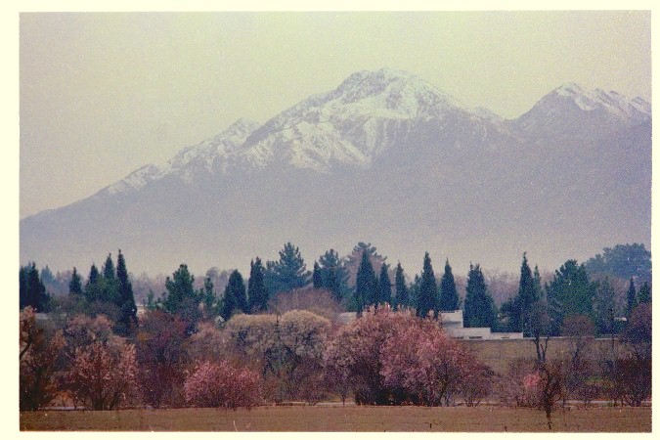

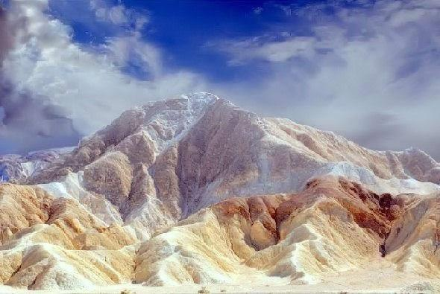

Koh-i-Chiltan is the summit of a steep, rocky mountain called Chiltan or Chehel-Tan (Persian/Balochi: 'Forty Bodies'). 'Lwarrh Saar' is the highest peak of Chiltan mountains range at 3,194 metres (10,479ft), it is the third-highest peak of Quetta after Zarghoon Ghar and Koh-i-Takatu, and fifth-highest peak of Balochistan. There are many juniper trees found in high ranges.